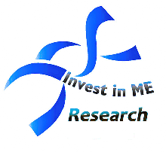

An Invest in ME Research initiative - [www.investinme.org](http://www.investinme.org)

For more details see [www.haveacuppaforme.org](http://www.haveacuppaforme.org)

# Tea & Coffee morning – All welcome!

## There is a text box here for you to fill in your local ME group details

**Saturday 12th May 2007**

All money raised will go towards vital biological research into Myalgic Encephalomyelitis (M.E.)

M.E. is a serious neurological illness that can leave people of all ages and from all walks of life bedbound and housebound for years at a time.

Come along to:

<place the venue address here>

From: <place the time here>